



**Human- machine interaction and visualization technology**

**Title：Nutrition Facts for McDonald's Menu**

**Student number 20202505004**

**Name** **平沛东Jeremy**

**College International college**

**Major Software engineering**

**Class Class 2**

**2023.05.30**

Contents

Abstract………………………………………………………………………………..2

I.Introduction………………………………………………………………………..…3

II.Methodology………………………………………………………….……………..4

III.Results…………………………………………………………………………...…5

IV.Discussion…………………………………………………………………………..6

V.Conclusion…………………………………………………………………………..6

References……………………………………………………………………………..6

Abstract

McDonald's is a large multinational restaurant chain in the world, with revenue of 23.18 billion dollars in 2022. It was founded in 1955 in Chicago, the United States, and has about 30,000 branches in the world. It mainly sells hamburgers, fries, fried chicken, soda, ice, salad, fruit and other fast food. Today, McDonald's is not only one of the most famous fast food brands in the world, but also has extensive influence in China. According to 2019 statistics, McDonald's has a 19.5 percent market share in China, leading the industry. McDonald's has a history of nearly 30 years in China and has grown rapidly since it entered the country in 1990. Today, McDonald's has more than 3,000 outlets in China, in more than 80 cities across the country. While many Chinese consumers are fond of McDonald's, more and more Chinese consumers are beginning to pay attention to the nutritional content of McDonald's menu. The nutrition Facts menu, obtained from McDonald's USA website, includes breakfast, beef burgers, chicken and fish sandwiches, French fries, salads, sodas, coffee and tea, milkshakes and desserts. This study aims to enable consumers to better understand the nutritional content of McDonald's menus through data visualization, so as to help consumers make more suitable and healthier ordering choices for themselves.

I.Introduction

McDonald's is a large multinational restaurant chain in the world, with revenue of 23.18 billion dollars in 2022. It was founded in 1955 in Chicago, the United States, and has about 30,000 branches in the world. It mainly sells hamburgers, fries, fried chicken, soda, ice, salad, fruit and other fast food.

With some 32,000 restaurants in 119 countries on six continents, McDonald's represents an American way of life in many countries. As the first and largest multinational fast food chain, McDonald's has been the focus of public discussion about food causing obesity, corporate ethics and consumer responsibility, representing a fast food culture that has been accused of affecting public health, such as high calories causing obesity, and lack of adequate balanced nutrition. Many people denounce it as junk food.

Today, McDonald's is not only one of the most famous fast food brands in the world, but also has extensive influence in China. According to 2019 statistics, McDonald's has a 19.5 percent market share in China, leading the industry. McDonald's has a history of nearly 30 years in China and has grown rapidly since it entered the country in 1990. Today, McDonald's has more than 3,000 outlets in China, in more than 80 cities across the country.

While many Chinese consumers are fond of McDonald's, more and more Chinese consumers are beginning to pay attention to the nutritional content of McDonald's menu. The nutrition Facts menu, obtained from McDonald's USA website, includes breakfast, beef burgers, chicken and fish sandwiches, French fries, salads, sodas, coffee and tea, milkshakes and desserts. This study aims to enable consumers to better understand the nutritional content of McDonald's menus through data visualization, so as to help consumers make more suitable and healthier ordering choices for themselves.

Questions include, but are not limited to: How many calories does the average McDonald's value meal contain? How much do beverages like soda or coffee contribute to total calorie intake? Does ordering grilled chicken instead of crackling add nutritional value to a sandwich? How about egg whites instead of whole eggs? What is the minimum number of items you can order from the menu to meet your nutritional needs for the day?

II.Methodology

Code analysis:

1. Number of menu items for each food category:

This code creates a bar chart that visualizes the number of menu items in each food category using the Category column in the DataFrame. The value_counts() function counts the number of occurrences of each category, and plot.bar() draws a bar graph.

2. Scatter plot and correlation between calories and fat calories:

This section creates a scatter plot to visualize the relationship between the "calories" and "fat calories" columns. The correlation between the two variables is calculated using the.corr() method, and the correlation coefficients are shown on the graph.

3. Bar chart of average trans fats by food category:

This code groups the data by food category and calculates an average for the "trans fat" column in each category. A bar chart is then created to show the average trans fat content in each category.

4. Bar chart of the top 5 foods with the highest saturated fat content:

In this section, a new column named "saturated_cholesterol" is added to the DataFrame by calculating the percentage of saturated fat based on cholesterol content. Then calculate the average percentage of saturated fat in each food. Select the top 5 categories with the highest percentage of saturated fat and plot them as bar charts.

5. Bar chart of average saturated fat of coffee and tea products:

This code filters the DataFrame so that it contains only items in the "coffee and tea" category. It then calculates the average saturated fat of each item and ranks these values in descending order.

6. Bar charts of average saturated fat per product in the smoothies and milkshakes category:

Like the previous section, this code filters the DataFrame to include only the items in the "Smoothies & Shakes" category. It calculates the average saturated fat content of each food item and ranks the numbers. The result is then plotted as a horizontal bar graph.

7. Bar chart of saturated fat per serving for beef and pork:

This code filters the DataFrame so that it contains only items in the "beef and pork" category. It calculates the average saturated fat content of each food item and ranks the numbers. The result is then plotted as a bar graph.

8. Bar chart of average saturated fat per salad category:

This code filters the DataFrame so that it contains only items in the "salad" category. It calculates the average saturated fat content of each food item and ranks the numbers. The result is then plotted as a bar graph.

9. Bar chart of average saturated fat of chicken and fish products:

This code filters the DataFrame to contain only items in the "Chicken & Fish" category. It calculates the average saturated fat content of each food item and ranks the numbers. The result is then plotted as a bar graph.

III.Results

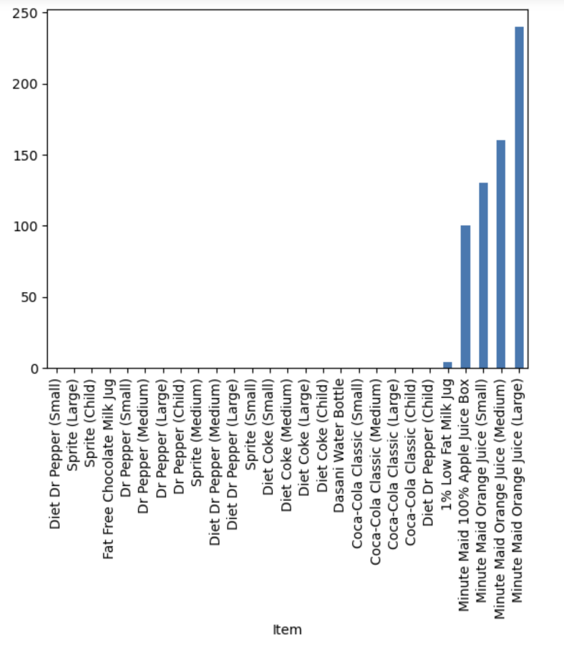

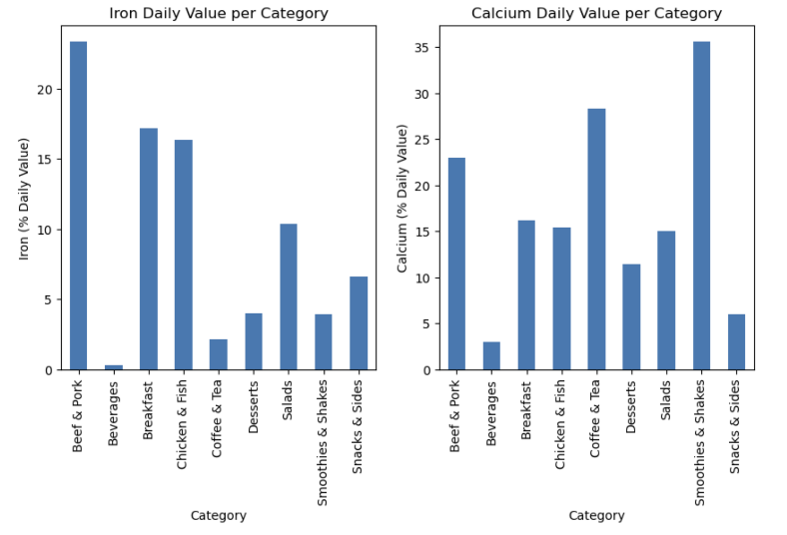

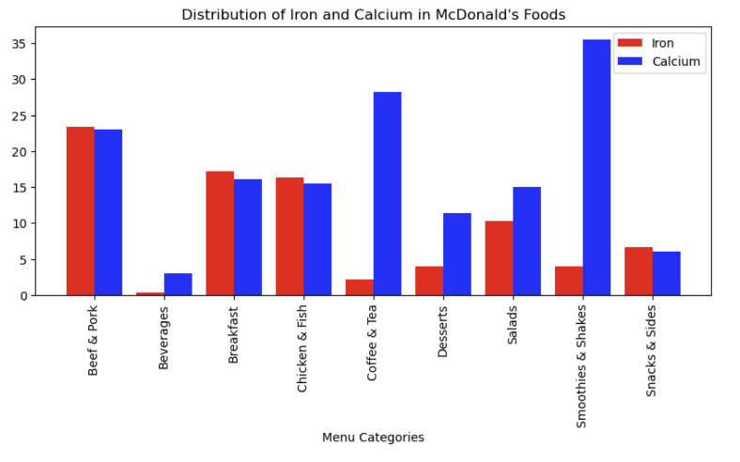

IV.Discussion

Based on an analysis of McDonald's menu data, here are some key observations and findings about the nutritional content of McDonald's menus:

Menu classification and number of dishes:

McDonald's menu includes several categories, the most common of which are "Chicken & Fish", "Beef & Pork" and "Beverages".

"Chicken & Fish" and "Beef & Pork" are the main meat options offered on McDonald's menu.

Beverages are available in the "Beverages" category.

Fat and cholesterol content:

Many of the items on the menu are high in fat and cholesterol.

Fat and cholesterol intake are closely related to calorie intake.

Main nutrients:

Most of the items on the menu are rich in carbohydrates and vitamin A.

Foods in the chicken and fish categories are higher in saturated fat.

Foods in the salad category are generally low in saturated fat.

Foods in the beverage category are usually higher in vitamin C.

Iron and calcium content:

There are differences in iron and calcium levels among different food groups on the McDonald's menu.

The iron content is higher in the categories of "Beef & Pork" and the calcium content is higher in the categories of "Chicken & Fish" and "Beverages".

V.Conclusion

Based on the above observations, we can draw the following conclusions:

The McDonald's menu offers food options in multiple categories, from meat to beverages, to meet different consumer needs and taste preferences.

Foods with high fat and cholesterol content should be carefully selected and consumed in the diet to maintain a healthy lifestyle.

McDonald's salad category offers healthy options low in saturated fat for health-conscious consumers.

The amount of iron and calcium varies from food group to food group, so consumers can choose the right foods for their individual nutritional needs.

Overall, the McDonald's menu offers a wide range of food options that consumers should choose and balance according to their nutritional needs and health goals. Consumers are advised to control the intake of high fat and cholesterol, choose foods rich in vitamins and minerals, and combine adequate exercise to maintain a healthy lifestyle.

References

[1] https://www.kaggle.com/datasets/mcdonalds/nutrition-facts

[2] https://baike.baidu.com/item/%E9%BA%A6%E5%BD%93%E5%8A%B3/163033?fr=aladdin

[3] https://baike.baidu.com/item/pandas/17209606?fr=aladdin

[4] https://baike.baidu.com/item/numpy/5678437?fr=aladdin

[5] https://baike.baidu.com/item/Matplotlib/20436231?fr=aladdin

[6] http://seaborn.pydata.org/

[7] https://baike.baidu.com/link?url=nEZ1U_UFmLyofl9qPwsYE-R3I07KEOkujROCRUnm_WZ5Gowta2PInA45Ak9UXxVmKhipPArsFLIQFYoeC2mDSX8vHux3sql5wRDwEpSATS9AUQxs8STRBJmsHkOH0J_a

[8] https://baike.baidu.com/item/%E6%95%A3%E7%82%B9%E5%9B%BE/10065276?fr=aladdin